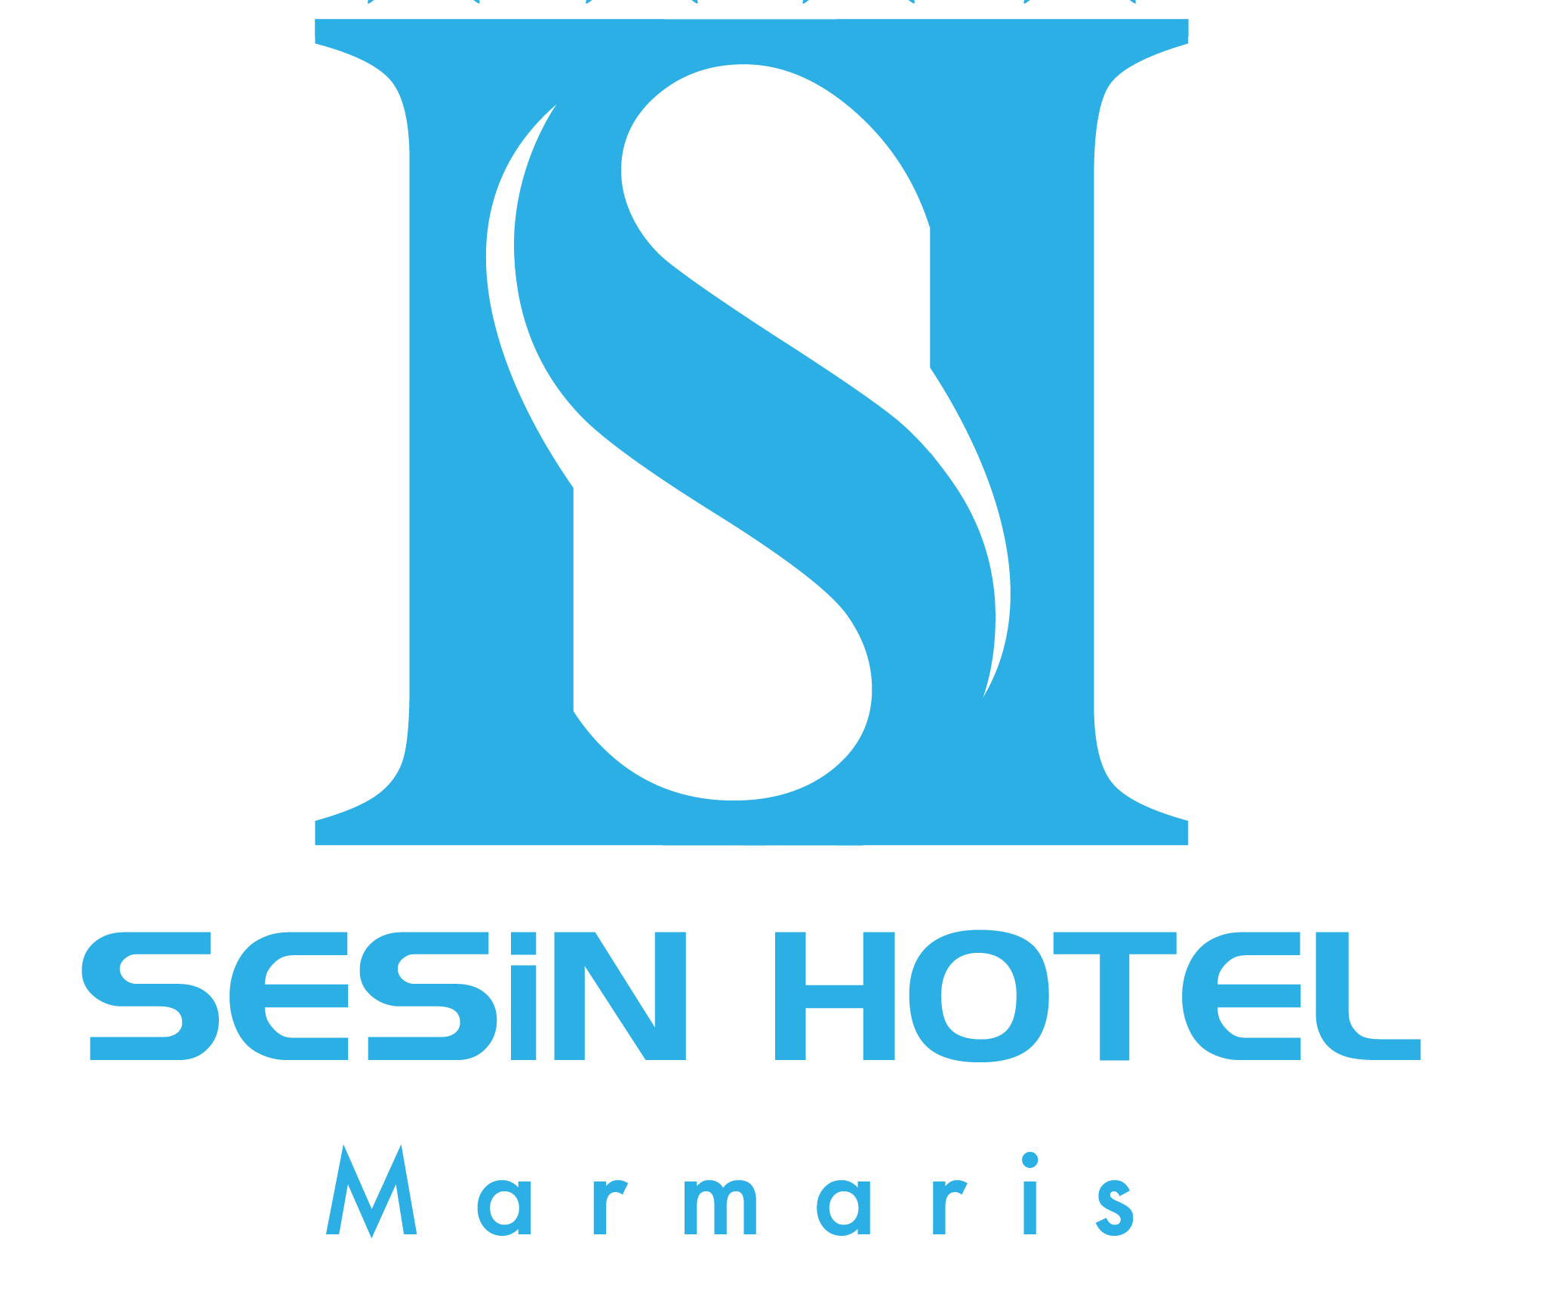
UK

AI

ALL INCLUSIVE POLICIES-2018

SERVICES
Breakfast : 07.30-10.00 hours, Main Restaurant, Open Buffet
Late breakfast : 10.00-11.00 hours, Main Restaurant (Set Menu)
Lunch-Snack : 12.30-14.00 hours, Main Restaurant, Open Buffet
Coffee Break : 17.00-18.00 hours, Garden Cafeteria, (Tea, Coffee, Cookies)
Dinner : 19:00-21:00 hours, Open Buffet

BEVERAGES : 10.00-23.00 hours, Free of Charge, Self Service
- Local Alcoholic drinks: Raki, Vodka ,Gin , Draft Beer, Red & White Wines.
- Soft Drinks: Cola, Fanta, Sprite, Soda, Water, Tea, Coffee, Concentrated Fruit Juices
(Drinks served only in a glass, Underage drinking is not acceptable!)
(SELF SERVICE)

ACTIVITIES (Free Of Charge)
Table Tennis : Free of Charge between hours; (10:00-22:00)
Fitness Center : Free of Charge between hours; 09:00-20 :00)
Swimming Pool : Opening Hours; (08:00- 18:00), No night Swimming!
Private Beach : Sunbeds,umbrellas, mattress free of charge
WiFi : Free of charge (login: please write your passport number password: please write your room number)

OTHER TERMS;
- Billiards, Air Hokey,Sauna,Massage,Play Station,Internet Cafe, Telephone, Safe Boxes, Laundry, Mini bar, Room Service,Ice Cream,Energy Drinks,Fresh Juices and Import drinks must be paid for. (Not within the terms of All Inclusive)
- Please do not bring any food and beverage items from outside to the hotel.
- Please do not use the Hotel towels at the pool and do not take to the sea.
- Swimming Pool Opening Hours; (08:00- 18:00), No night Swimming!
- The Air Condition working 24 hours, self controling by start-stop button on remote controller.

We take this opportunity to thank you for choosing to stay with us and wish you a pleasant holiday.

Hotel Management.

